How to download attendance lists for OP JAK projects at MFF CUNI?

1. First login to <https://cis.mff.cuni.cz/>
2. Then you cna select english (top banner)
3. Click on the „Absenses“ Tab

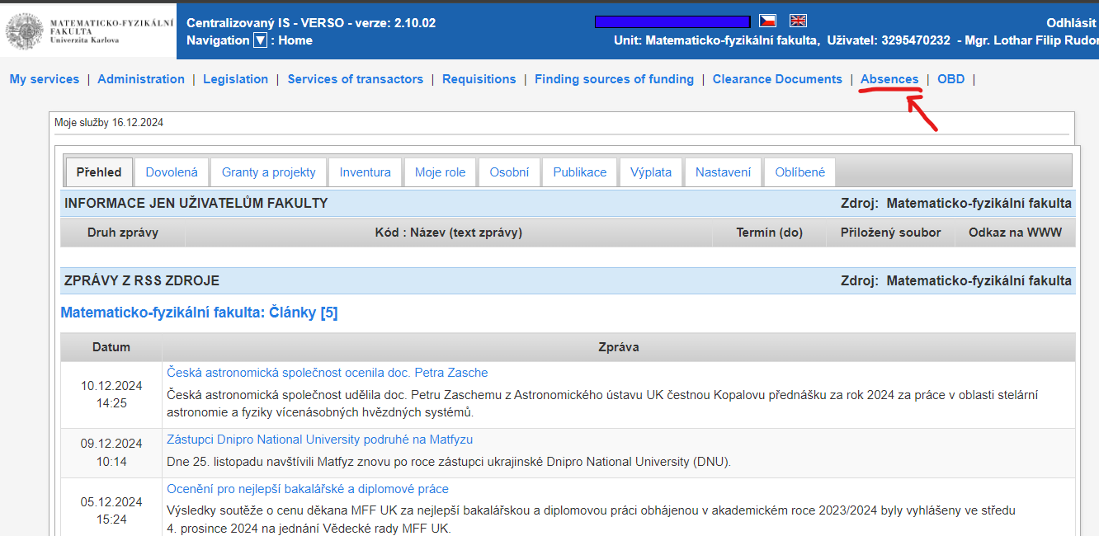

1. Then click on the „Attendance list“ tab

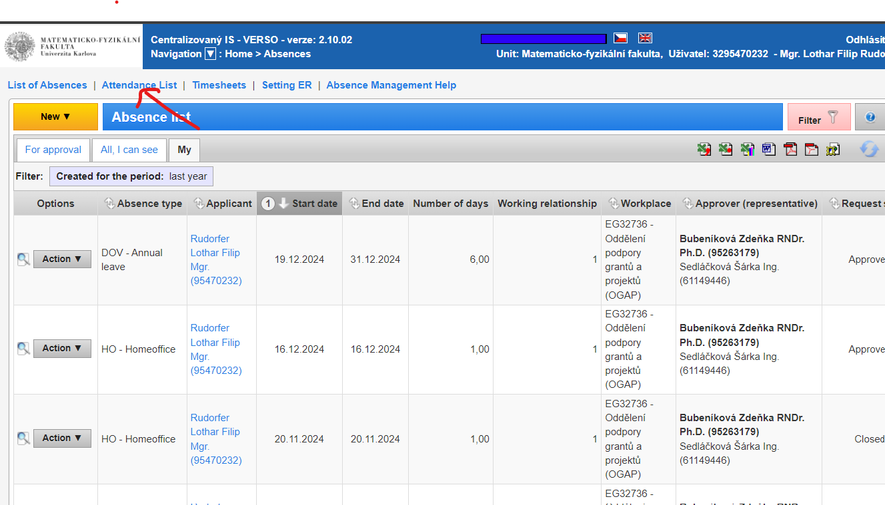

1. There you can choose „My“ tab to view your attendance lists for each month

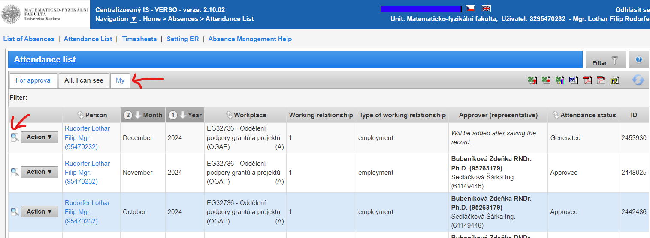

1. By selecting the icon of magnifying glass next to the „action“ button you may view the attendance for a particular month

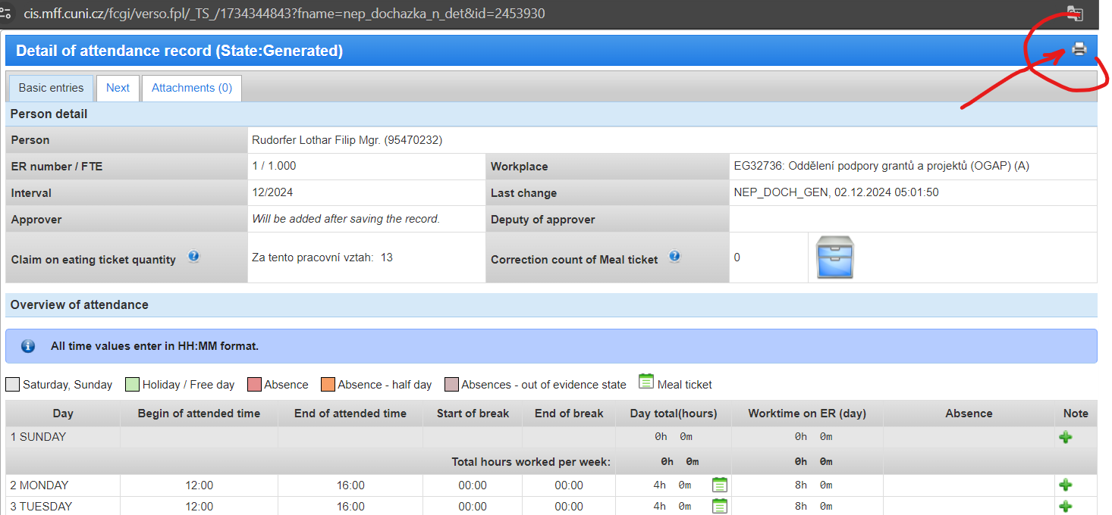

1. Simply click on the „printer icon“ and the pdf will download
2. Send the pdf to your project officer at OGAP