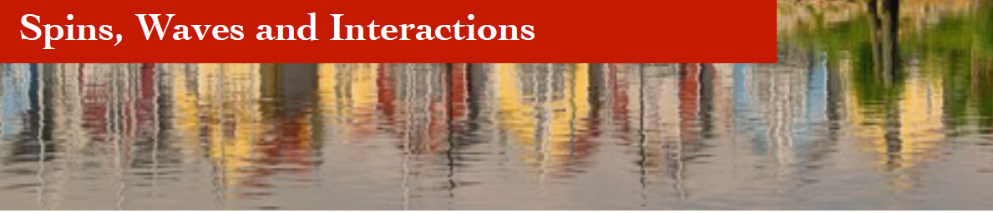

**Registration: Spins, Waves and Interactions 2025  
 September 1 – September 3, 2025, Krupp Kolleg, Greifswald**

**1 Personal Information**

|  |  |
| --- | --- |
| First and last name |  |
| Affiliation (name tag) |  |
| Email address |  |

**2 Contribution**

|  |  |
| --- | --- |
| Title of contribution |  |

Contribution: invited poster

**3 Social Events**

|  |  |
| --- | --- |
| Dinner Sep 1 |  |
| Dinner Sep 2 |  |
| Excursion Sep 3 |  |
|  |  |

Please return until July 31, 2025 (latest) to [michaela.lammel@uni-konstanz.de](mailto:michaela.lammel@uni-konstanz.de).

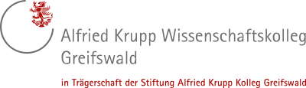

Graciously sponsored by: